1. Phase 3: AI based diabetes prediction system

**Introduction:**

Diabetes is a chronic medical condition affecting millions of people worldwide. It is characterized by high blood sugar levels and can lead to serious health complitionif not managed effectively. Early detection and proactive management of diabetes are crucial in preventing these complications. Artificial Intelligence (AI) has emerged as a powerful tool to assist in the prediction and management of diabetes. This introduction provides an overview of an AI-based diabetes prediction system and its significance.

**Dataset:**

The dataset can be taken from the following below link,

**Dataset link:https://www.kaggle.com/datasets/mathchi/diabetes**

**Data collection and preprocessing:**

Data collection is a fundamental aspect of developing an AI-based diabetes prediction or management system. To build an effective and accurate system, you need a diverse and comprehensive dataset. Here are some key considerations for data collection in an AI-based diabetes

**Data source:**

* Demographics: Collect information about age, gender, ethnicity, and socioeconomic status.

**Data variables:**

Ensure data quality by addressing missing values, outliers, and inconsistencies.

Validate data accuracy and consistency by cross-referencing information from different sources.

**Data sources:**

Validate data accuracy and consistency by cross-referencing information from different sources.

**Data volume:**

Collect a sufficiently large dataset to train and test AI models effectively. The required dataset size may depend on the complexity of the AI model and the number of features.

**Program:**

import numpy as np

import matplotlib.pyplot as plt

from sklearn.preprocessing import scale, StandardScaler

from sklearn.model_selection import train_test_split, GridSearchCV, cross_val_score

from sklearn.linear_model import LogisticRegression

from sklearn.linear_model import LogisticRegression

from sklearn.svm import SVC

from sklearn.neural_network import MLPClassifier

from sklearn.tree import DecisionTreeClassifier

from sklearn.ensemble import RandomForestClassifier

from sklearn.ensemble import GradientBoostingClassifier

from lightgbm import LGBMClassifier

from sklearn.model_selection import KFold

import warnings

warnings.simplefilter(action = "ignore")

from sklearn.model_selection import KFold

import warnings

warnings.simplefilter(action = "ignore")

df = pd.read_csv("/content/diabetes.csv")

df.head()

**output:**

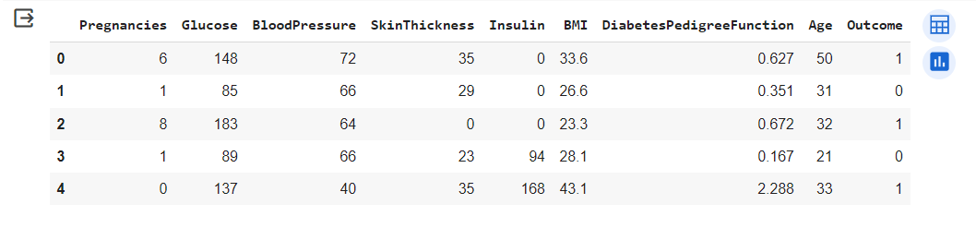

df.info()

**output:**

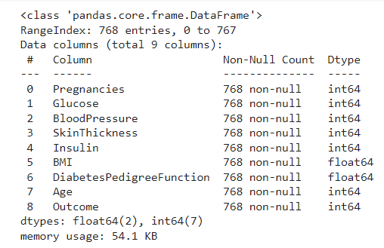

df.describe([0.10,0.25,0.50,0.75,0.90,0.95,0.99])

**output:**

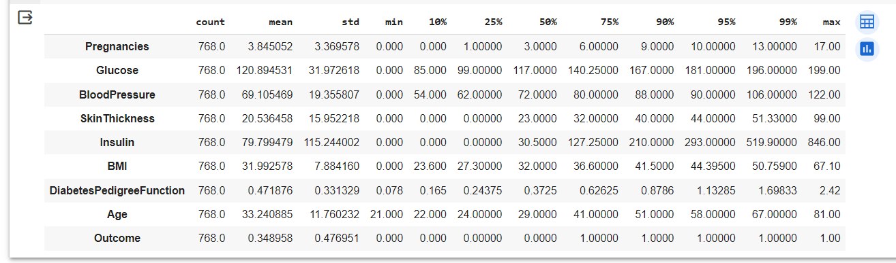

**Conclusion:**

In conclusion, an AI-based diabetes system represents a promising and transformative approach to managing diabetes, offering numerous benefits to patients, healthcare providers, and the healthcare system as a whole. This innovative technology harnesses the power of artificial intelligence and machine learning to revolutionize the way we understand, monitor, and treat diabetes